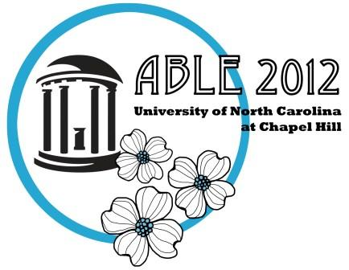

**Call for Mini-Presentations on TA (Teaching Assistant) Training**

**ABLE, 2012 Conference**

**Association for Biology Laboratory Education**

The University of North Carolina at Chapel Hill   
June 19-22

Host: Barbara Stegenga (able2012@unc.edu)

We are interested in having a series of TA training mini-workshops that run concurrently with other mini-workshops on Friday June 22nd. Therefore, we are encouraging the submission of mini-workshop presentations on the topic of TA training so that we have at least one TA training mini in each of the four mini-workshop sessions.

If you are interested in submitting a TA training mini-workshop proposal, please indicate below the general topic and format of the session:

Topic (check all that apply):

________ Currently used training methods (pedagogical practice)

________ Assessment of training methods (pedagogical research)

________ Solutions for issues related to TA training

________ Training international TAs

________ Other: _________________________________________________________

Format (check all that apply):

________ Discussion

________ Activity

________ **Check this line if you are interested in collaborating with presenters on the same topic. You will be contacted by Barbara Stegenga or Kristen Miller via email to inform you if we are able to match you up with potential collaborators.**

Your Name: _______________________________________________________

Contact email address: ______________________________________________

Please submit this form, along with your standard mini-workshop proposal as described at <http://www.ableweb.org/conf/miniworkshops.htm> to **both** Ralph Preszler ([rpreszle@nmsu.edu](mailto:rpreszle@nmsu.edu)) and Kristen Miller ([krmiller@uga.edu](mailto:krmiller@uga.edu)) no later than March 1, 2012.

Deadline to submit mini-presentation proposals on any topic is March 15th: <http://www.ableweb.org/conf/able2012/miniworkshops.htm>