
ECOLOGIES Quick Start Guide
Scan the QR code on the right for a synopsis of the ECOLOGIES game. NOTE: we are modifying some of the standard rules, so be sure to note these differences.
Goal: Be the first person to reach 10 victory points (the game may end before a player reaches 10 points - see ‘Ending the Game’ below for details). For Round 1, remove all factor cards from the deck. Shuffle these cards back into the deck for Round 2.
Start: Form groups of 4-5 players. Each player receives 7 cards to begin the game (there is no limit on the amount of cards you can hold).
Card Types
Biome cards Organism cards Factor cards
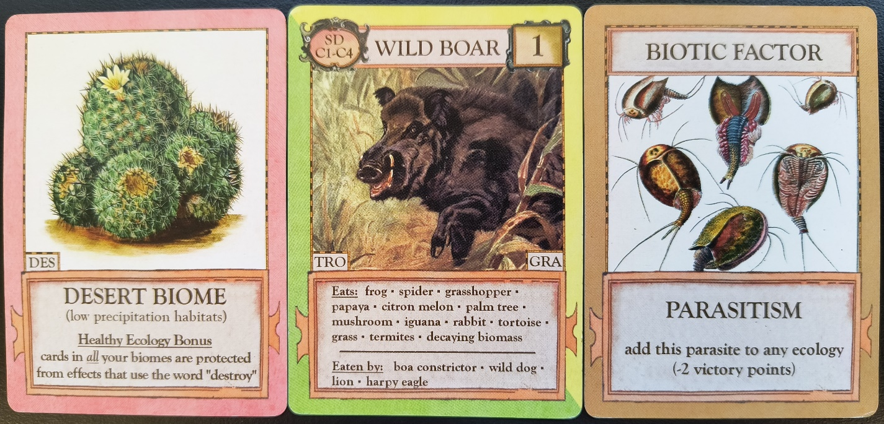
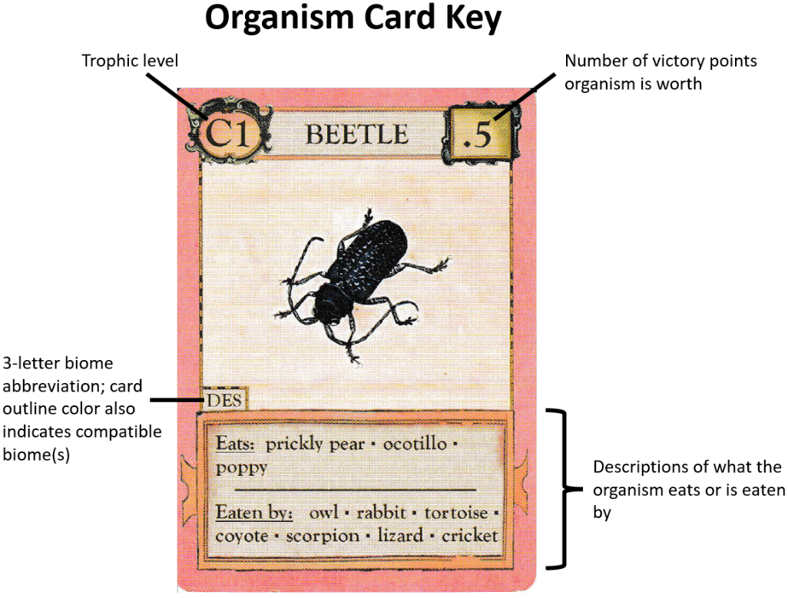
Playing a Turn
- Required: Draw 2 cards from the deck (these should not be kept visible to others). *NOTE: only the ‘draw card’ step is required; you can skip any or all the following steps (listed below) during your turn if you wish*
- (Optional step) Use Healthy Ecology Bonus, if applicable (note that some bonuses should be used at the start of your turn, e.g., those that allow you to draw extra cards, redraw cards or steal cards from opponents).
- (Optional step) Trade any number of unplayed cards with other players. This can be attempted at any time during your turn, but is recommended before playing any cards.
- (Optional step) Play up to 3 cards; this includes playing a biotic/abiotic factor card.
- (Optional step) Purchase cards from the deck at a 4:1 rate, i.e., discard 4 unplayed cards to draw 1 new card. You can make multiple purchases per turn, as long as you’re willing to give up the necessary cards. Alternatively, you can choose to destroy an Ecology and receive 1 new card per 3 cards removed/discarded.

Building ECOLOGIES
  - Start building your Ecology by playing a biome card (this counts as one of your three ‘plays’ for a turn; see Step 3, letter ‘d’, above).
  - Once you’ve played a biome card, the second card you add to your Ecology must be a producer (P) – this is because producers do not require any other organism to survive. *NOTE: there is no limit on the amount of producers or other organisms you can connect to a single biome, as long as they are compatible*
  - Once a producer is in play, you can play a primary consumer (C1) or scavenger (SD) that eats that producer, followed by other consumers (C2/C3/C4) that eat one or more of the existing organisms in your Ecology. Note: A non-producer organism cannot be played until one of the organisms it eats also exists in that ecology. Also, cards do not have to be played in a 1:1 ratio, e.g., multiple consumers can be played off a single producer or prey card.
  - You can have multiple ECOLOGIES in play at the same time.
  - You can rearrange the cards across your biomes during your turn, e.g., if another player destroys a producer in your biome, you can shift the consumer cards to other biomes (if they are compatible/have a food source); otherwise, those cards must be discarded.

Card placement: Create distinct rows (left) or partially stack cards (right). Producers occupy the same row as the biome card, with C1/SD cards in the row above it. Additional rows are created for C2/C3/C4 cards, in that order.
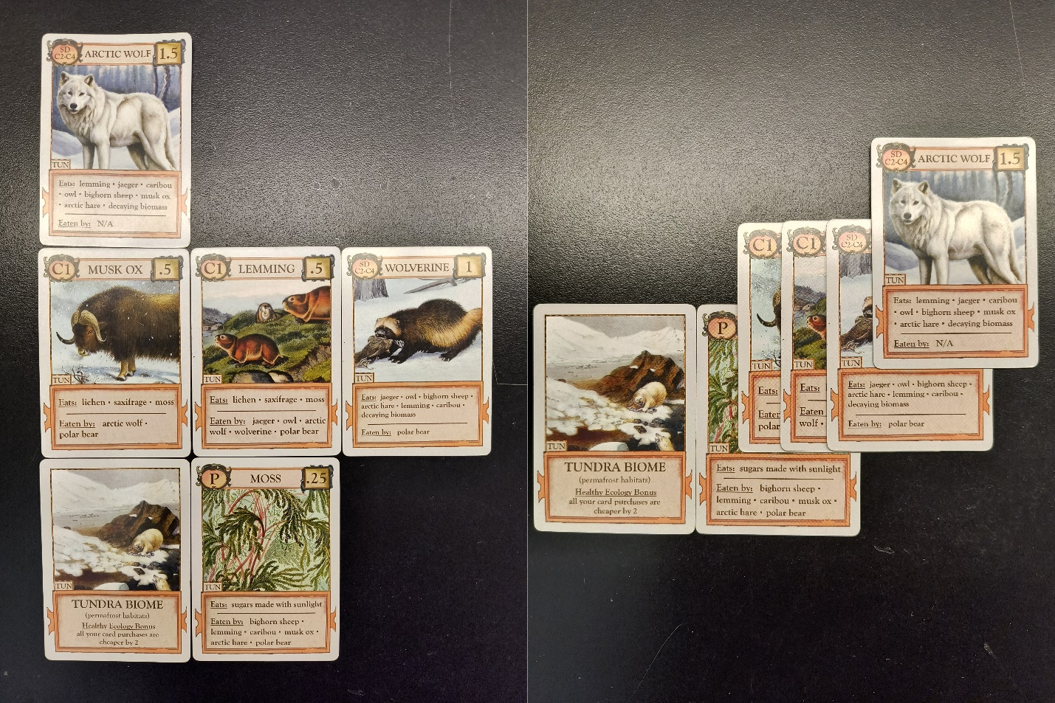

Interpretation of healthy ecology bonuses for four biomes
Biome | Healthy Ecology Bonus (card description) | Interpretation (how to apply/use)
Grassland | You may destroy an organism acting as a C3 or above every other turn | Once a healthy Grassland ecology bonus is achieved, on your next turn and then every other turn of yours, you may destroy an organism acting as a C3 or above
Marine | Draw one extra card per turn | Once a healthy Marine ecology bonus is achieved, on your subsequent turns draw three cards (instead of two)
Temperate Forest | You can redraw each new card once (rejects go to the bottom of the deck) | Once a healthy Temperate Forest ecology bonus is achieved, on your subsequent turns you can redraw each new card once, placing rejects onto the bottom of the deck
Tropical Forest | Steal an unplayed card every other turn (a random card from an opponent’s hand) | Once a healthy Tropical Forest ecology bonus is achieved, starting on your next turn and every 2nd turn of yours, take a random card from one opponent’s hand; does not count as a drawn card

Ending the Game
The game is over when a player has earned 10 victory points. If the deck runs out, re-shuffle the discard pile to form a new one. If both the deck and discard pile are empty, continue playing until a new discard pile is formed. If both piles are empty and an entire round passes without anyone playing any cards, the game ends and the player with the highest score wins.

